Annex 1: Government Response Assessment Scheme
Parliamentary queries on infrastructure projects, requests for additional documentation or parliamentary recommendations require government response assessment and follow-up to ensure the timeliness and the quality of government’s reaction. This assessment may be carried out by committees or Members of Parliament (MPs) either for individual responses to parliamentary requests or systematically for all parliamentary interventions in order to ensure accountability or efficiency of implementation. This assessment scheme provides some suggested standardized procedures for assessing government responses while maintaining appropriate follow-up mechanisms. A response and follow-up procedures classification system can help to systematically assess the adequacy of government reactions.
This scheme or framework should be tailored to the specific infrastructure project under investigation. To simplify the process of cooperation between parliament and the government, this may already have been accounted for in legislation on infrastructure projects. For example, by providing regular project reports and updates and timely responses to inquiries or recommendations from committees.
Response Adequacy Assessment Criteria:
Responsiveness Analysis:
- Complete response to all requests within specified timeframe
- Sufficient substance and quality in the response
- Concrete steps in response to the request can be identified
- Appropriate response to recommendations, including timeframe, resource allocation and implementation planning adequacy
- Specific commitments with clear timelines and responsible departments or agencies
- Fullfilling stakeholder consultation and engagement commitments
Implementation Likelihood Assessment:
- Specificity and reliability of the response
- Specific process- or project-related measures committed
- Specified timeframe
- Technical feasibility of proposed implementation approaches
- Resource adequacy for recommended actions
- Institutional capacity for implementation management
- Risk identification and mitigation planning
Accountability Mechanism Evaluation:
- Legal reporting and response obligations of departments or agencies
- Follow-up options and established accountability mechanisms
- Progress reporting procedures and timeline commitments
- Performance measurement and evaluation frameworks
- Oversight coordination and information sharing agreements
- Corrective action procedures and specified information requirements
Response Classification System:
Comprehensive Response (Green Status):
- All queries, requests or recommendations addressed with comprehensible responses or specific commitments
- Clear spezification of implemented or planned measures or procedures
- Clear implementation timeline with milestone markers
- Adequate resource allocation and institutional arrangements
- Robust accountability and monitoring procedures
Partial Response (Yellow Status):
- Majority of queries, requests or recommendations addressed with some gaps
- Some implemented or planned measures or procedures adressed
- Implementation commitments with minor timing or resource concerns
- Adequate accountability procedures with limited monitoring
- Follow-up required for unaddressed recommendations
Inadequate Response (Red Status):
- Significant queries, requests or recommendations unaddressed or vaguely committed
- Implemented or planned measures or procedures poorly or not specified
- Implementation timelines unrealistic or poorly defined
- Insufficient resource allocation or institutional commitment
- Limited accountability and monitoring procedures
Follow-up Procedures by Response Classification:
Green Status Follow-up:
- Quarterly progress reporting and performance monitoring
- Annual implementation review and outcome assessment
- Stakeholder satisfaction evaluation and feedback integration
- Lessons learned documentation for future oversight
Yellow Status Follow-up:
- Monthly progress monitoring and issue resolution
- Supplementary questioning and committee attention
- Enhanced stakeholder engagement and transparency measures
- Targeted follow-up recommendations for gap areas
Red Status Follow-up:
- Immediate government explanation and revised response requirement
- Committee hearing and public accountability sessions
- Enhanced oversight and monitoring procedures
- Escalation to senior government leadership and political intervention

Annex 2: Detailed Outline of an Impact Assessment
Depending on the environmental planning laws and regulations, an impact assessment should cover the following topics:
- Project overview, location, features and purpose.
- Explanation of the approval process, including how the various regulations and requirements have been adhered to and assessed.
- Justification for the project, including alignment to national plan and developmental goals.
- Alternatives that were considered for the project, including options analysis, design process and refinement.
- Detailed project description, including maps, designs, construction materials, utilities (water or power), drainage, technology (if required), property acquisition and site access.
- Description of how construction will be done, the stages and activities, where depots are located, how materials and waste from the project will be transported, how noise and pollution from the project will be managed.
- Information on how consultation and stakeholder engagement on the project will be undertaken and managed and feedback from any consultation already completed.
- Depending on the nature of the project there may be specific chapters on the following:
- air quality | - noise and vibration
- human health risk | - social and economic assessment
- urban design and visual amenity – how the project will integrate into the existing landscape, any rectifications that are required | - land and property impacts and acquisition and disposal of property
- soil and water quality | - contamination
- flooding and drainage | - biodiversity
- heritage and cultural items – if there is an impact on monuments or sites of special national, cultural or religious significance | - green house gas
- climate change risk and adaptation | - sustainability

Attached to the impact assessment should be appendices with detailed reports on investigations, mitigation and management plans that have been signed and agreed to. If a contract has already been signed with a principal or contractor, the contract should be attached to the impact assessment or, at a minimum, there should be a reference to the relevant clauses of the contract where compliance with the items in the impact assessment is detailed.

Example of Impact Assessment: WestConnex motorway project: M4-M5 Link, Sydney, Australia

Annex 3: Detailed Cost-benefit Analysis
Under Phase 3 of the project lifecycle, the structure of a cost-benefit analysis (CBA) is discussed and examples of the benefits are provided.
Example of the structure of a CBA
- Problem definition (scope)
- Identifying and measuring the impacts
- Costing the impacts
- Discounting future costs and benefits
- Identify the risks and uncertainties
- Procurement approach (if applicable)
- Outline the governance and assurance for the project
- Make a recommendation

Cost benefit analysis (CBA) can also be packaged into a document called a business case or project appraisal document. The government of United States, United Kingdom, Canada, Australia and New Zealand mandate business cases and the preparation of a CBA. A business case builds on the eight items above and includes more analysis—financial, economic and policy—to determine if the project represents value for money for the government. The European Union promotes, but does not require a CBA and uses a collection of methodologies known as Economic Appraisal Vademecum (EAV) for the economic evaluation of EU co-financed projects, which is a streamlined process that intends to ensure that whether a project offers value for money and to provide the necessary information for decision makers at varous points throughout the project cycle. References and guidelines for different examples of methods used are included at the links below.

Canadian Treasury Business Case Guide

Economic Appraisal Vademecum (2021–2027): General Principles and Sector Applications

South Korea General Guidelines for a Pre-feasibility Study

Annex 4: Example of Risk Analysis
Risk management is a structured process for identifying, assessing and prioritizing, and then addressing potential risks or uncertainties that could negatively impact on completing a task or project. Risk analysis is part of the risk assessment process. To conduct an analysis, a specific risk management framework is generally used. There are international standards that can be used as a guideline for completing a risk assessment and for establishing a risk management framework (ISO 31000:2018 series) for large infrastructure projects.

The assessment and management of risks is a key area of analysis that should inform the decision-making process for large infrastructure projects. Risk assessments and risk management plans should be done and updated at during the first four of the five phases of the project lifecycle (Phases 1–4). Effective early identification and plans to manage risks before a project begins construction can assist in reducing costs, mitigating the impact of a project and ensuring efficient delivery of the project.

Figure 1 outlines the process that can be used to assess, identify, analyse, treat and record and report on risks.

Figure 1 Risk Management Framework (ISO31000:2018)
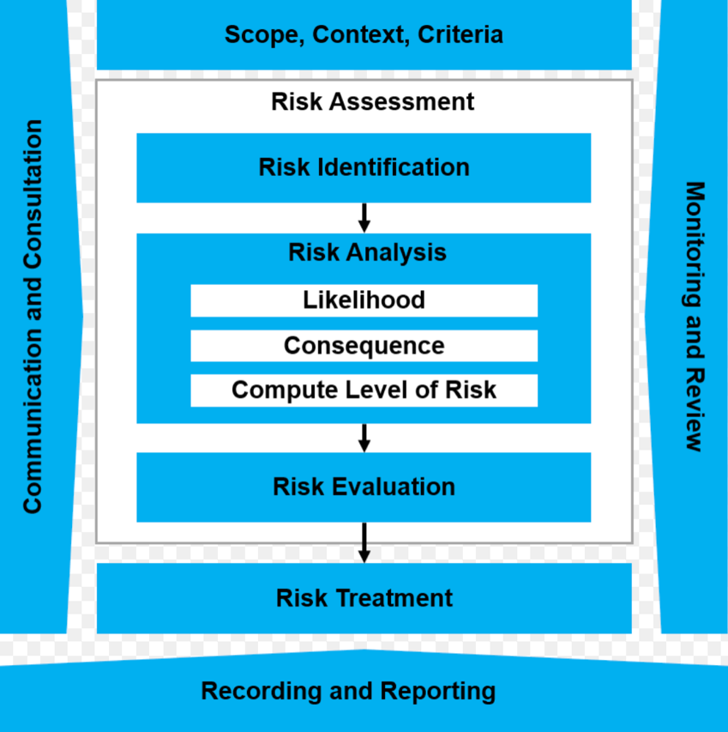

To analyse risks, the use of a matrix to categorize the likelihood of the risk, and also the consequence and level of risk, should be used. Figures 2 provides an example of a risk matrix and Figure 3 shows an analysis of the risk of delay on a project.

Figure 2: Example of a Risk Matrix
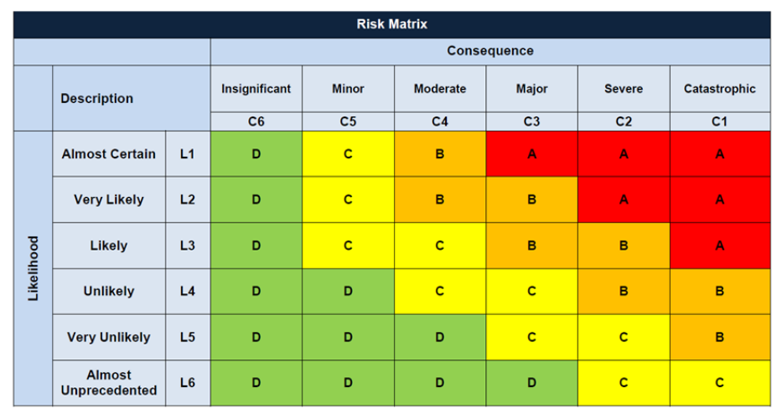

Figure 3: Example of Risk to Delay Categorization
Risk Consequence
Rating | C6 | C5 | C4 | C3 | C2 | C1
Description | Insignificant | Minor | Moderate | Major | Severe | Catastrophic
Project Delivery | Insignificant project delay (<1)  Capex over project budget by <1%  No reduction in functionality/ scope | Minor project delay (1 day to <1 week) with no public impacts  Capex over project budget by 1%–2%  Scope or functionality partially impaired with no impacts on delivery or quality | Moderate project delay (<1% to max 1 month) with no public impacts  Capex over project budget 2%–3%  <1% reduction in functionality or scope  Benefit realization partially impaired but still adds value and is economically sound | Major project delay (<10% to max of 5 months)  Capex over project budget by 3%–5%  <10% reduction in functionality or scope  Cost benefit analysis may not have supported the program go ahead  Publicly announced portion, milestone or completion date missed | Severe delay (<15% to max of 9 months)  Capex over project budget by 5%–8%  <15% reduction in functionality or scope | Total blow out in time (>9motnhs or >15%)  Capex over budget by more than 8%  >15% reduction in functionality or scope  Failure to realize benefits  Future funding likely needed to rectify or deliver outcomes
Following this analysis, risks are then evaluated and then treated. There are number of ways that risks can be treated within a project. The following list provides some examples:

- Retaining the risk by informed decision ie prioritsing it
- Averting the risk by removing a source or cause of the risk
- Avoiding the risk entirely by not undertaking the activity
- Sharing the risk with other parties
- Accepting the risk to achieve certain objectives or opportunities
- Changing the likelihood and/or consequence of the risk through modifying controls in place
Depending on the treatment chosen, specific agreements may be entered into, such as the transfer of risk to the contractor for constructing the project in a certain way (if the contractor is a specialist in a specific area) or changes in the design or scope of the project to reduce a risk. Risks are also an important consideration during the tender and procurement of a contractor to build a project. The costs of the project may vary greatly depending on the risk appetite of a contractor to bare certain risks. This is also why risks must be recorded and reported throughout the project lifecycle. At Phases 1 and 2, a detailed investigation of the risks will inform the option chosen and the design of the project. The use of a risk framework and risk analysis helps to ensure decision makers have enough information to make a choice on whether to proceed with the project at Phase 3 (The Investment Decision phase) and on the procurement methodology. Once the project is in construction at Phase 4, decision makers need to ensure that risks are being treated adequately.

Annex 5: Example of Procurement Methodology
The OECD’s Recommendation on Public Procurement (focused on the delivery of public projects) and the World Bank’s Procurement Framework (focused on the financing of development works) provide some examples of best practice in procurement, frameworks and standards; areas for improvement; and templates. A procurement methodology is the way a project will be delivered and should consider the resources available to decision makers to build the project and evaluate the costs. It should aim to deliver the project in a way that achieves value for money.
As such, the procurement methodology is closely linked to the risks and costs of a project and is informed by a detailed analysis and consideration of both. Government should have enough information from the risk evaluation and options analysis to chose a model to deliver the project in the most efficient and effective way. The procurement method should be chosen at Phase 3 (The Investment Decision phase) as it will form part of the cost for the project. There are a number of methods available to government to deliver projects:
- Design-procure-build: The government either uses in-house resources or procures designers to create detailed plans, then a procurement process is held to obtain tenders from construction companies to construct the project.
- Design-build: A single entity engaged by the government handles both the design and construction.
- Construction only: The government department responsible for the project (e.g. transport, water or education) uses departmental resources to manage and design the projectand undertake physical works.
- Alliance contract: Similar to design-build but using a more collaborative model where the client (government) and service providers (contractors) form a single team and share collective responsibility for project risks and rewards (also known as a pain/gain share). In this scenario, they make decisions jointly.
- Public-Private Partnerships (PPP): A collaboration between a public entity and private sector partners to deliver a project.
There are a number of different steps to procuring a project and these should be provided for in national laws, regulations and guidelines and monitored through anti-corruptions bodies. Procurement usually includes the following:
- Plan: Identify project needs, objectives (time, cost, quality), and risks.
- Source: Finalize requirements and establish the criteria for evaluating potential suppliers or contractors.
- Evaluate: Assess tenders and proposals against the pre-set criteria to demonstrate value for money.
- Award: Confirm funding and approve the purchase to proceed.
- Manage: Monitor performance, manage contracts, handle variations and address disputes.
Parliaments should receive copies of tender evaluations of projects so that they can be satisfied that the procurement process has achieved value for money and for transparency to ensure the contract has been awarded in a fair manner. Many countries will publish contracts (part or all) for transparency. In some cases, this is required under law. Once a contractor has begun delivery of the project, parliaments should receive regular reports on how the contractor is meeting performance requirements under the contract and be advised of variations to the contract. Parliaments should also have visibility of how claims and disputes will be managed and receive reports of the value of any claims or ongoing disputes.
Best Practice: Implementing the OECD Recommendation on Public Procurement in OECD and Partner Counties, 2020–24 Report

Annex 6: Example of a construction schedule
All infrastructure projects must have documentation of the timeframes and steps to build the project. The construction schedule should be developed during Phases 1 and 2 and finalized at Phase 3 of the project lifecycle. The construction schedule will become a source of information for the government for how the project is being delivered, if a contractor has been engaged to build the project, or if the project will be provided by the relevant government departments. The construction schedule forms the basis of reports to parliament and other key external stakeholders who are impacted by the project.

The schedule should be broken down into steps and include the materials required for each step, resources needed and the timeframe. A detailed construction schedule should include the following:

- Project milestones: start and finish of each event
- The time it will take for each for step
- Who is accountable for each task
- Any dependencies, such as any interfaces with third parties including access to land or utilities (see Appendix 7), any compliance with regulations or laws
- Materials required
- Resources and equipment
- Budget and contingencies

There are a number of different applications that can be used to visually display this information, Gantt charts for detailed and complex projects and various project management packages or even excel for less complex projects.

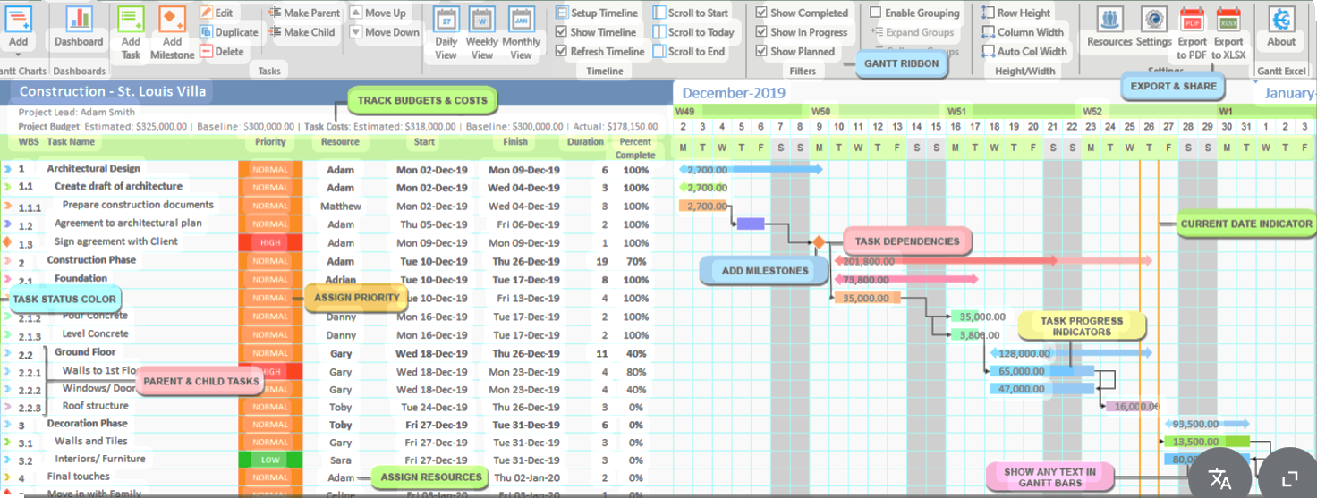

Annex 7: Example of an Interface Agreement
An interface agreement for a large infrastructure project is a formal written agreement or contract that defines roles, responsibilities and requirements for different actors or entities that interact or overlap during the delivery of a large infrastructure project, or projects, or at different stages of the delivery of a project if being built in stages. Agreements will often address access to land, property or utilities, safety, physical integration points (e.g. rail lines, roads and waterways) and will focus on the coordination of activity between third parties (e.g. contractors building a project or operators of a road, rail line or utility).

Interface agreements often arise out of the risk assessment for the project. Entering into an interface agreement removes the risks to delivery of the project that arise from the rights and powers of a third party. This is closely tied to managing the timeframes for delivering parts of the project and also managing the costs of the project. For example if access is required over a line to pour concrete for a road bridge that will go over the rail line, planning when this activity occurs is crucial. If access is not planned and agreed to there could be a waste in materials (concrete) and, conversely, the costs of not having the rail line in operation may need to be paid.

In order to draft an interface agreement there needs to be an understanding of:
- The works that will be the subject of the interface agreement and how a delay to delivery of the works would impact the overall construction programme.
- The legal rights held by the third party.

Depending on the nature of the works, their may be multiple parties to the agreement. Using the example above of the bridge over the railway, if the bridge was for pedestrians only, the final owner of the bridge, for example, the council or municipality, will need to be a party to the agreement, as they will take carriage of the bridge once it opens. Another example could be a new power supply required for a train or metro. Parties to the agreement could include the contractor building the metro, the local authority or land owner where the new power supply is to be located and the power supply company (government or private operator). Depending on the nature of the works, there are generally four key considerations that an interface agreement should address:
- Design review procedure: The procedure that faciliatates the third party to the agreement to have input into the design of the structure on their land or adjacent to the activity that is being carried out.
- Completion procedure: If the third party has a role in the completion of the works, if they become the eventual owner of the new part of a project or if the third party interacts with the activity being carried out.
- Provision of services by the third party: If the contractor needs the participation of the third part in inspecting or approving a part of the project prior to completion.
- Statutory approvals or other processes: If there are any government or industry regulations that need to be adhered to and complied with and how these are agreed between the parties.

Example: Power Services Construction Works Interface Agreement

